**Translate text and documents by using the Azure AI Translator service**

**Azure Text Translation**

Azure Text Translation is a cloud-based REST API feature of the Translator service that uses neural machine translation technology to enable quick and accurate source-to-target text translation in real time across all [supported languages](https://learn.microsoft.com/en-us/azure/ai-services/translator/language-support).

Text Translation API enables quick and accurate source-to-target text translations in real time. The Text Translation software development kit (SDK) is a set of libraries and tools that enable you to easily integrate Text Translation REST API capabilities into your applications. Text Translation SDK is available across programming platforms in C#/.NET, Java, JavaScript, and Python.

**Text translation features**

**Text Translation data residency**

* Feature: **Translator Text**

**Document Translation**

Document Translation is a cloud-based machine translation feature of the [Azure AI Translator](https://learn.microsoft.com/en-us/azure/ai-services/translator/translator-overview) service. You can translate multiple and complex documents across all [supported languages and dialects](https://learn.microsoft.com/en-us/azure/ai-services/language-support) while preserving original document structure and data format. The Document translation API supports two translation processes:

* [Asynchronous batch translation](https://learn.microsoft.com/en-us/azure/ai-services/translator/document-translation/overview#asynchronous-batch-translation) supports the processing of multiple documents and large files. The batch translation process requires an Azure Blob storage account with storage containers for your source and translated documents.
* [Synchronous single file](https://learn.microsoft.com/en-us/azure/ai-services/translator/document-translation/overview#synchronous-translation) supports the processing of single file translations. The file translation process doesn't require an Azure Blob storage account. The final response contains the translated document and is returned directly to the calling client.

**Asynchronous batch translation**

Use asynchronous document processing to translate multiple documents and large files.

**Batch key features**

**Batch development options**

You can add Document Translation to your applications using the REST API or a client-library SDK:

* The [**REST API**](https://learn.microsoft.com/en-us/azure/ai-services/translator/document-translation/reference/rest-api-guide). is a language agnostic interface that enables you to create HTTP requests and authorization headers to translate documents.
* The [**client-library SDKs**](https://learn.microsoft.com/en-us/azure/ai-services/translator/document-translation/quickstarts/client-library-sdks) are language-specific classes, objects, methods, and code that you can quickly use by adding a reference in your project. Currently Document Translation has programming language support for [**C#/.NET**](https://learn.microsoft.com/en-us/dotnet/api/azure.ai.translation.document) and [**Python**](https://pypi.org/project/azure-ai-translation-document/).

**Batch supported document formats**

The list includes the common file extension, and the content-type if using the upload API.



**Batch Legacy file types**

Source file types are preserved during the document translation with the following **exceptions**:

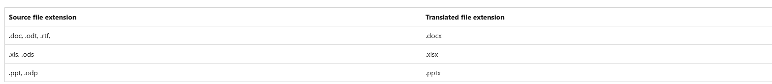

**Batch supported glossary formats**

Document Translation supports the following glossary file types:

**Synchronous translation**

Use synchronous translation processing to send a document as part of the HTTP request body and receive the translated document in the HTTP response.

**Synchronous translation key features**

**Synchronous supported document formats**

**Synchronous supported glossary formats**

Document Translation supports the following glossary file types:

**Document Translation data residency**

Document Translation data residency depends on the Azure region where your Translator resource was created:

* Feature: **Document Translation**
* Service endpoint: **Custom: <name-of-your-resource.cognitiveservices.azure.com/translator/text/batch/v1.1**

**Create a Translator resource**

**Create your resource**

With your Azure account, you can access the Translator service through two different resource types:

1. [**Single-service**](https://portal.azure.com/#create/Microsoft.CognitiveServicesTextTranslation) resource types enable access to a single service API key and endpoint.
2. [**Multi-service**](https://portal.azure.com/#create/Microsoft.CognitiveServicesAIServices) resource types enable access to multiple Azure AI services by using a single API key and endpoint.

**Complete your project and instance details**

After you decide which resource type you want use to access the Translator service, you can enter the details for your project and instance.

1. **Subscription**. Select one of your available Azure subscriptions.
2. **Resource Group**. You can create a new resource group or add your resource to a pre-existing resource group that shares the same lifecycle, permissions, and policies.
3. **Resource Region**. Choose **Global** unless your business or application requires a specific region. If you're planning on using the Document Translation feature with [managed identity authorization](https://learn.microsoft.com/en-us/azure/ai-services/translator/document-translation/how-to-guides/create-use-managed-identities), choose a geographic region such as **East US**.

1. **Name**. Enter a name for your resource. The name you choose must be unique within Azure.
2. **Pricing tier**. Select a [pricing tier](https://azure.microsoft.com/pricing/details/cognitive-services/translator) that meets your needs:
   * Each subscription has a free tier.
   * The free tier has the same features and functionality as the paid plans and doesn't expire.
   * Only one free tier resource is available per subscription.
   * Document Translation is supported in paid tier only. The Language Studio supports the S1 and D3 instance tiers. If you just want to try Document Translation, select the Standard S1 instance tier.
3. If you create a multi-service resource, the links at the bottom of the **Basics** tab provide technical documentation regarding the appropriate operation of the service.
4. Select **Review + Create**.
5. Review the service terms, and select **Create** to deploy your resource.
6. After your resource has successfully deployed, select **Go to resource**.

**Authentication keys and endpoint URL**

All Azure AI services API requests require an endpoint URL and a read-only key for authentication.

* **Authentication keys**. Your key is a unique string that is passed on every request to the Translation service. You can pass your key through a query-string parameter or by specifying it in the HTTP request header.
* **Endpoint URL**. Use the Global endpoint in your API request unless you need a specific Azure region or custom endpoint. For more information, see [Base URLs](https://learn.microsoft.com/en-us/azure/ai-services/translator/reference/v3-0-reference#base-urls). The Global endpoint URL is api.cognitive.microsofttranslator.com.

**Get your authentication keys and endpoint**

To authenticate your connection to your Translator resource, you need to find its keys and endpoint.

1. After your new resource deploys, select **Go to resource** or go to your resource page.
2. In the left navigation pane, under **Resource Management**, select **Keys and Endpoint**.
3. Copy and paste your keys and endpoint URL in a convenient location, such as Notepad.

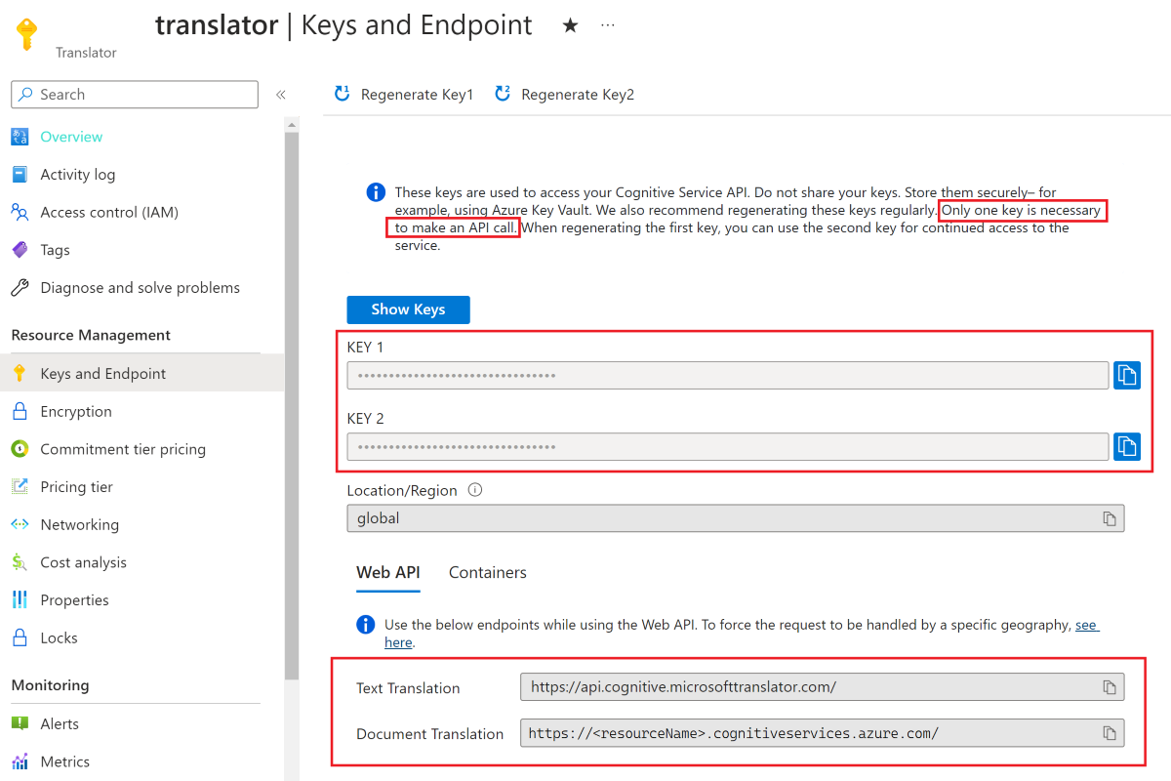

**Translate Text SDK**

**Run your application**

Here's a snippet of the expected output:

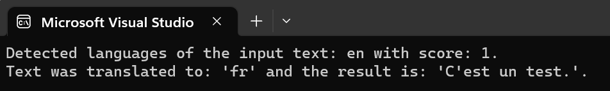

**Translate Text REST APIs**

**Run your application**

Here's a snippet of the expected output:

**Document Translation SDK**

**Prerequisites**

**To get started, you need:**

* An active [Azure account](https://azure.microsoft.com/free/cognitive-services/). If you don't have one, you can [create a free account](https://azure.microsoft.com/free/).
* A [single-service Translator resource](https://portal.azure.com/#create/Microsoft.CognitiveServicesTextTranslation) (not a multi-service Azure AI services resource). If you're planning on using the Document Translation feature with [managed identity authorization](https://learn.microsoft.com/en-us/azure/ai-services/translator/document-translation/how-to-guides/create-use-managed-identities), choose a geographic region such as East US. Select the Standard S1 Standard Service Plan (Pay-as-you-go) or C2, C3, C4, or D3 Volume Discount Plans.
* An [Azure Blob Storage account](https://portal.azure.com/#create/Microsoft.StorageAccount-ARM). You'll [create containers](https://learn.microsoft.com/en-us/azure/storage/blobs/storage-quickstart-blobs-portal#create-a-container) in your Azure Blob Storage account for your source and target files:
  + Source container. This container is where you upload your files for translation (required).
  + Target container. This container is where your translated files are stored (required).

**Storage container authorization**

You can choose one of the following options to authorize access to your Translator resource.

**✔️ Managed Identity**. A managed identity is a service principal that creates a Microsoft Entra identity and specific permissions for an Azure managed resource. Managed identities enable you to run your Translator application without having to embed credentials in your code. Managed identities are a safer way to grant access to storage data and replace the requirement for you to include shared access signature tokens (SAS) with your source and target URLs.

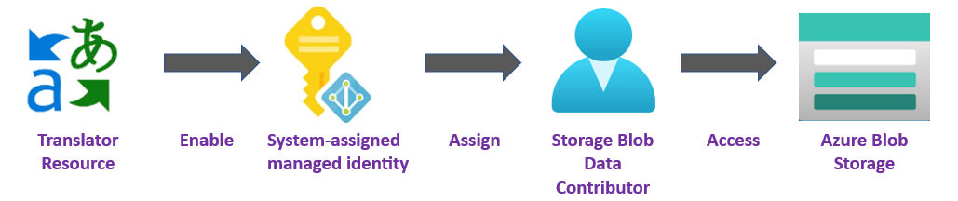

**✔️ Shared Access Signature (SAS)**. A shared access signature is a URL that grants restricted access for a specified period of time to your Translator service. To use this method, you need to create Shared Access Signature (SAS) tokens for your source and target containers. The sourceUrl and targetUrl must include a Shared Access Signature (SAS) token, appended as a query string. The token can be assigned to your container or specific blobs.

* Your **source** container or blob must designate **read** and **list** access.
* Your **target** container or blob must designate **write** and **list** access.

**Asynchronous translation code sample**

**Synchronous translation code sample**

**Run your application**

Here's a snippet of the expected output:

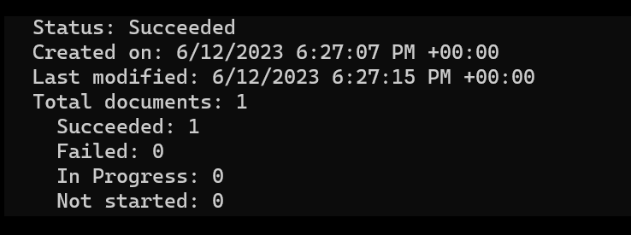

**Document Translation Language Studio**



